Assignment 1

CSC 355

Sept 30, 2016

Ryan Woodward

V00857268

## University of Victoria Department of Computer Science CSC 355 Digital Logic and Computer Design

**ASSIGNMENT 1 DUE Friday September 30 AT BEGINNING OF CLASS**

Neatness Counts! (5% of assignment grade allocated to following this format specification)

It is expected that answers to assignments are either typed or written *extremely* neatly. In all cases, the Karnaugh Maps formats below *must* be used, either copied and edited to add the required bits and circles or printed and written on. Circuits much be drawn using a circuit drawing program.

1. Determine the radix r given that (2362)r = (36D)16 (show all your work).

(36D)16 = 3 * 162 + 6 * 161+ 13 * 160

= (877)10

(2362)r = 2r3 + 3r2 + 6r1 + 2r0 = 877

2r3 + 3r2 + 6r – 875 = 0

The factors of 875 are 875. 175, 125, 35, 25, 7, 5, 1

Using a cubic factor table we test 7 to see if it factors

|  |
| --- |
| **Factor** |
| 7 |
| x^3 | x^2 | x^1 | x^0 |
| 2 | 3 | 6 | -875 |
|  | 14 | 119 | 875 |
| 2 | 17 | 125 | 0 |

Since the final sum adds to 0, it proves that the base radix is 7

1. **Show the bit configuration that represents the decimal number 251 in**
   1. **Binary**

|  |  |
| --- | --- |
| **251** | 1 |
| 125 | 1 |
| 62 | 0 |
| 31 | 1 |
| 15 | 1 |
| 7 | 1 |
| 3 | 1 |
| 1 | 1 |
| 0 |  |

**(251)10 = (1111 1011)2**

* 1. **BCD**

2 = 0100, 5 = 0101, 1 = 0001

(251)10 = BCD = 0100 0101 0001

* 1. **ASCII (7 bit)**

2 in ASCII = 011 0010

5 in ASCII = 011 0101

1 in ASCII = 011 0001

* 1. **ASCII with even parity**

2 ASCII with even parity LSB sent = 1011 0010

2 ASCII with even parity MSB sent = 0110 0011

5 ASCII with even parity LSB sent = 0011 0101

5 ASCII with even parity MSB sent = 0110 1010

1 in ASCII with even parity LSB sent = 1011 0001

1 in ASCII with even parity MSB sent = 0110 0011

1. Simplify the following expressions, using Boolean algebra, into minimum sum of products form. Show each Boolean Algebra rule used in the simplification.
   1. $\left(D+\overline{C}\right)\left(A+C\right)\left(\overline{D}+B\right)\left(C+D\right)$ 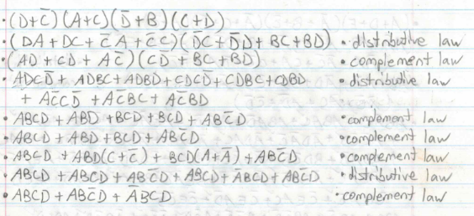
   2. $\left(A+D+E\right)\left(\overline{A}+B+\overline{C}\right)\left(\overline{A}+C+\overline{D}\right)\left(A+\overline{C}\right)$ 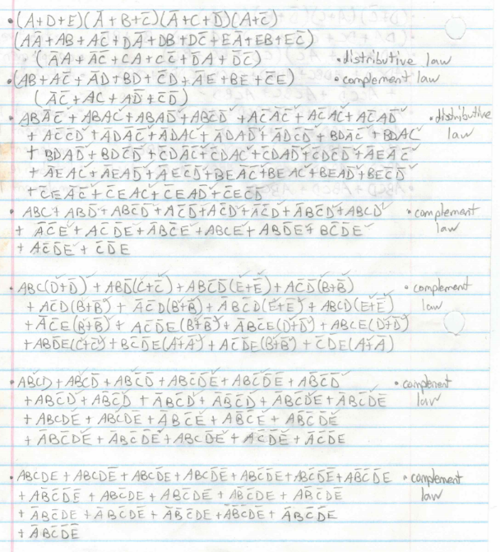

1. Use Karnaugh maps to simplify the following Boolean expressions, giving the result in Sum of Products form:

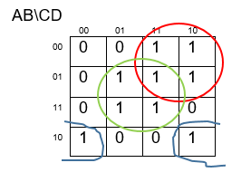

= C+ BD + A

* 1. F(A,B,C) =

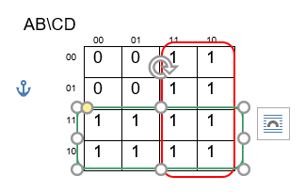

= C + A

* 1. F(W,X,Y,Z) =

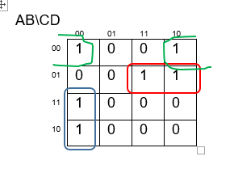

= A + + BC

* 1. F(w,x,y,z) = (3, 4, 9, 13) + d(1, 5, 7, 14, 15).

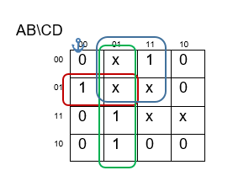

= $\overline{A}D$ + $\overline{C}$ D + $\overline{A}B\overline{C}$

1. Use Karnaugh maps to simplify the following Boolean expressions, giving the result in Product of Sums form.
   1. **F(W,X,Y,Z) = $\left(X+Y+\overline{Z}\right)\left(W+\overline{Y}+\overline{Z}\right)\left(\overline{W}+Y+\overline{Z}\right)\left(W+\overline{X}+\overline{Z}\right)\left(\overline{W}+X+Y\right)$**

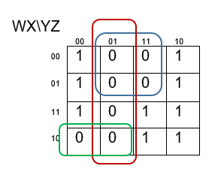

$\overline{F}$ = $\overline{W}$ Z + Z + W

F = (W + )(Y + )(

* 1. **F(w,x,y,z) =**

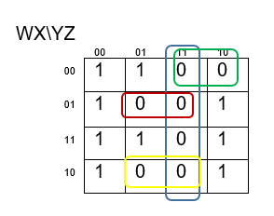

F = (W + X + )()(W + )(

* 1. **F(w,x,y,z) =**

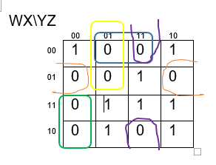

F = (W + Y + )(W + X + )(X + (W +

* 1. **F(w,x,y,z) = (1, 3, 7, 13) + d(5,6,8, 9, 12, 14)**

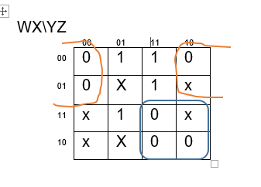

F = (W + Z)($\overline{W}+ \overline{Y}$)

1. Design circuits as specified below. In each case assume that all variables are available in both true and inverted form (i.e., there is no need to put inverters on the main inputs). Gates may have any fan-in up to 4. More marks will be awarded for circuits that use fewer gates.
   1. **a two level circuit for $b(c + \overline{a}) + \overline{b}(c + d) +\overline{a}d$ using only AND, OR gates;**

F = $\overline{A}$ B + C + $\overline{B}D$ when simplified

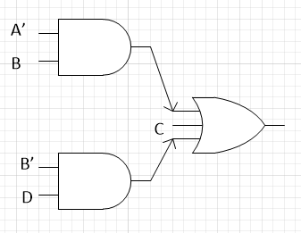

* 1. **a circuit for $\overline{a}bc + \overline{a}\overline{b}d + \overline{a}c$ using NAND gates only**

F = $\overline{A}\overline{B}$ D+ AC when simplified

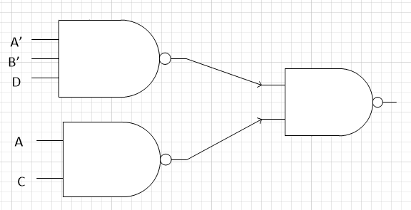

* 1. **a circuit for $a\overline{b}\overline{c} + \overline{a}cd + a\overline{b}c + abd$ using NOR gates only.**

F = (A + D)(A + C)($\overline{B}+D)$

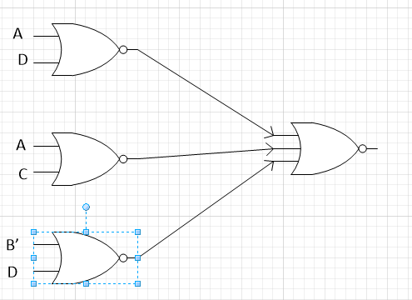

1. A switching network has 3 inputs (w, x and y) and 2 outputs (a and b). The output variables, a and b, represent the first and second bits, respectively of a binary number, N. N equals the total number of the inputs which are “0”. For example, if w=1, x=0. y=1, then a=0, b=1, representing 1 “0” input. A second example, if w=1, x=0. y=0, then a=1, b=0, representing 2 “0” inputs.
   1. Find the minterm expansion for a and b. Express the answer in abbreviated notation (with Σ or π).

|  |  |  |  |  |
| --- | --- | --- | --- | --- |
| X | Y | Z | A | B |
| 0 | 0 | 0 | 1 | 1 |
| 0 | 0 | 1 | 1 | 0 |
| 0 | 1 | 0 | 1 | 0 |
| 0 | 1 | 1 | 0 | 1 |
| 1 | 0 | 0 | 1 | 0 |
| 1 | 0 | 1 | 0 | 1 |
| 1 | 1 | 0 | 0 | 1 |
| 1 | 1 | 1 | 0 | 0 |

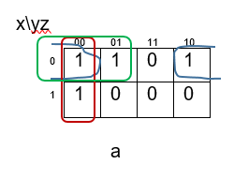 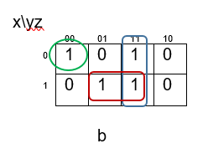

F(A) = , F(B) =

* 1. **Find the maxterm expansion for a and for b. Express the answer in abbreviated notation (with Σ or π).**

, =

* 1. **Provide a circuit, using AND and OR gates for this switching network.**

